LESSON 2:
Population:Definition,methods of conducting census-de-facto,dejura,;population change:balancing equations,natural increase,rate of natural increase,growth rate,doubling limit,Demographic transition theory,beyond the transition ,

POPULATION:
Definition:The total number of people living in a country,an area or a community. It can also refer to a group of organisms of one species that interbreeds and live in in the same place at the same time.

CENSUS: Is a procedure of systematically acquiring and recording information about the number of a given population.

METHODS OF CONDUCTING A CENSUSES
DEFACTO: refers to physically present in an area concepts and involves the counts of all persons physically present in the country. This includes both residents and non-residents alike and recording them in the local area where they are found at the time of census.
DEJURE: involves persons who are considered normally to reside in the area ,irrespective of where they might have been at the time of the census. This implies that persons absent at the time of country will or at least can ,eventually return to their home country.

FACTORS WHICH PREVENT A CENSUS FROM BEING COMPLETELY ACCURATE
- Administration difficulties: linguistics,financial remissions,and human resources
- Number of people to be counted, that's is the greater the number ,the greater the difficulty
- Area to be covered hence the vast the area,the difficulty
POPULATION CHANGE
As births and deaths are constantly taking place,the population size is constantly changing. So, all that census purports to give is a kind of snapshot of the situation at the particular moment in a process of continuous change.
Additionally,there are other factors to be considered which are are associated with this change as well as rates involved. The basic Demographic Equation is one of the means of analyzing this dynamic situation.

THE BASIC DEMOGRAPHIC BALANCING EQUATIONS
This is the most fundamental relationship in formal demography. It's formula can be written as:
Pt=P+(B-D)+(Migration in➖Migration out)
Pt=population at the end of period
P=population at the beginning of the period
B=Births
D+Deaths
In other words,population of an area at time t or at the end of the period being examined is equal to the population at the beginning of the period plus the number of births less the number of deaths plus the number of migration in to the area and less migration out.
NATURAL INCREASE
The difference between the number of births and the number of deaths gives the “natural increase”,while the difference between migration in and migration out gives the “net migration”,the equation can as well be written as :
POPULATION CHANGE =NATURAL INCREASE + NET MIGRATION

The equation can be expressed in terms of rates by dividing each element by the population at mid-year. Then the rate of population change is as follows:

Pt-Po=(B-D) + Mig in- Mig out)
MYP

Where:
Pt=population at the end of the period
Po=population at the beginning of the period
B=Births
D=Deaths
Mig in=Migration in
Mig out=Migration out
MYP=Mid year population
So the difference between the birth rate and the death rate is the rate of natural increase, and the difference between the migration in and migration out rate is the net migration rate.
Hence we can now say that:
Growth rate = rate of natural increase +/- Net migration rate

The annual growth rate over a period is usually expressed as an average by using the ordinary interest rate formula from then business arithmetic :

Pt=Po(1+r)^{t}
Where :
Po=Population at the beginning of the period
Pt=population at the end of the period
t=Number of years in a period
r=Average Annual rate of growth
DOUBLING LIMIT:
Is the period of time required for a quantity to double in size or value like a population
Td=Log(2)/Log(1+r/100)=

The doubling point of a population assuming the growth rates remain constantly throughout,can be calculated using the following formula:

Doubling point = 70/ R
R-Growth rate annual

DEMOGRAPHIC TRANSITION THEORY
The demographic transition theory is a generalized description of the changing pattern of mortality, fertility and growth rates as societies move from one demographic regime to another
There are four stages to the classical demographic transom odes:
Stage 1:pre transition: There is high birth rates, and high fluctuating death rates

Stage 2: Early transition: During the early stages of the transition,the death rates begins to fall. As birth rates remain high, the population starts to grow rapidly.

Stage 3:late transition: Birth rates start to decline. The rate of population growth decelerates
Stage 4:post transition. This is the final stage both birth rates and death rates become low so that once, they tend to off-set each other , producing a new equilibrium.
These four stages are depicted on the graph below.
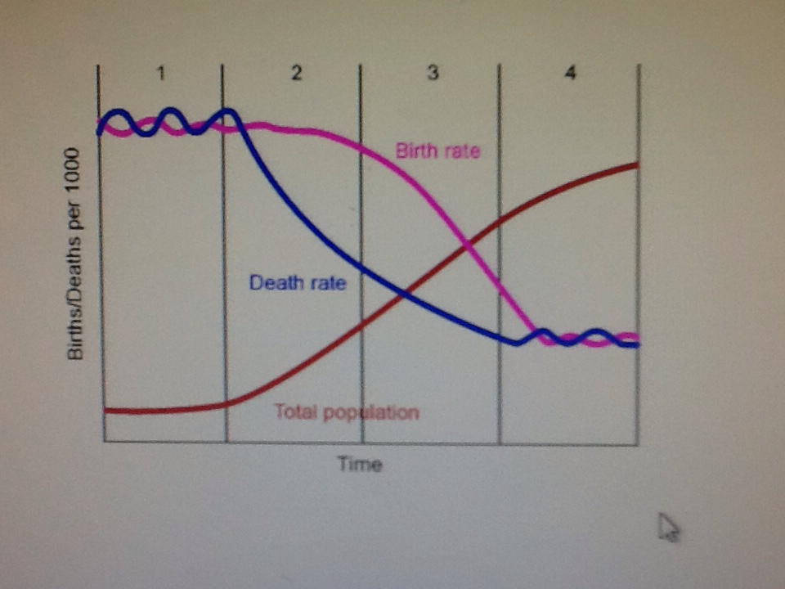

BEYOND THE TRANSITION THEORY
The demographic transition in low income countries
There are a number of differences between historical demographic transitions which occurred Europe,,North a aeries, Canada and Australia and the demographic transition occurring in the rest of the world.
- Timing and speed of modern demographic transition: Mortality fell fast and growth rates are so high even to today hence huge population growth.
- Causes of high population growth in developing countries
- Socioeconomic development: increased GDP
- Public health INTERVENTIONS
- Antibiotics
- Vaccinations
- Nutrition
- Fertility decline
- Social Economic development:-in rural areas, the benefits of children are high like giving help in the land and are insurance for old age care.. As societies urbanize, the cost of children increases and wealth begins to flow from parent to child hence rational decision to have few children. Nevertheless, the decision to have few children can only be realized if methods for fertility control are accessible.
- Reduction in child mortality: couples have many children to insure against future losses,
- Family planning
POPULATION DYNAMICS:
The term refers to the ever-changing interrelationships among the set of variables that influence the demographic makeup of populations as well as variables that influence the growth and decline of population sizes. Among the factors that relate to the size as well as the age and sex composition of populations are:
- fertility,
- death rates,
- and migration.
PRINCIPLES OF POPULATION POPULATION GROWTH
Population growth refers to changes in the size of a population with time.
  - Non-Living things : Growth is linear and in a straight line.
  - Living things: Growth is exponential..j shape.
Thus a population can not grow indefinitely for their limiting factors which prevent the increase. This include the environment and food availability

The number of organisms of a population that a particular environment can support over an indefinite period of time is known as its carrying capacity.

LIMITS TO POPULATION GROWTH
- Diseases
- Competition
- Temperatures
- Storms
- Floods

